**Ex. No. : 01 Date: 28/04/2025**

**Register No.: 221701050 Name: D Sathiya Sri**



**GUI Components**

**Aim**

Develop an application to change the font and color of the text and display a toast message when the user presses the button.

***Procedure:***

1. Create a new Android project (Empty Views Activity, Kotlin).
2. Design the layout (activity_main.xml) with a TextView and a Button.
3. (Optional) Add a custom font in res/font/.
4. Write Kotlin code (MainActivity.kt) to:

* Change text color.
* Change text font.
* Show a Toast message on button click.

1. Run and test the app.

***AndroidManifest.xml***

<?xml version="1.0" encoding="utf-8"?>

<manifest xmlns:android="http://schemas.android.com/apk/res/android"

xmlns:tools="http://schemas.android.com/tools">

<application

android:allowBackup="true"

android:dataExtractionRules="@xml/data_extraction_rules"

android:fullBackupContent="@xml/backup_rules"

android:icon="@mipmap/ic_launcher"

android:label="@string/app_name"

android:roundIcon="@mipmap/ic_launcher_round"

android:supportsRtl="true"

android:theme="@style/Theme.Exp1"

tools:targetApi="31">

<activity

android:name=".MainActivity"

android:exported="true">

<intent-filter>

<action android:name="android.intent.action.MAIN" />

<category android:name="android.intent.category.LAUNCHER" />

</intent-filter>

</activity>

</application>

</manifest>

***Activity_main.xml***

<?xml version="1.0" encoding="utf-8"?>

<RelativeLayout xmlns:android="http://schemas.android.com/apk/res/android"

android:layout_width="match_parent"

android:layout_height="match_parent"

android:padding="20dp">

<TextView

android:id="@+id/myTextView"

android:layout_width="wrap_content"

android:layout_height="wrap_content"

android:text="Hello, Change Me!"

android:textSize="24sp"

android:layout_centerHorizontal="true"

android:layout_marginTop="100dp"/>

<Button

android:id="@+id/changeFontButton"

android:layout_width="wrap_content"

android:layout_height="wrap_content"

android:text="Change Font"

android:layout_centerHorizontal="true"

android:layout_below="@id/myTextView"

android:layout_marginTop="50dp"/>

<Button

android:id="@+id/changeColorButton"

android:layout_width="wrap_content"

android:layout_height="wrap_content"

android:text="Change Color"

android:layout_centerHorizontal="true"

android:layout_below="@id/changeFontButton"

android:layout_marginTop="20dp"/>

</RelativeLayout>

***MainActivity.kt***

package com.example.exp_1

import android.graphics.Color

import android.graphics.Typeface

import android.os.Bundle

import android.widget.Button

import android.widget.TextView

import android.widget.Toast

import androidx.appcompat.app.AppCompatActivity

class MainActivity : AppCompatActivity() {

private lateinit var myTextView: TextView

private lateinit var changeFontButton: Button

private lateinit var changeColorButton: Button

override fun onCreate(savedInstanceState: Bundle?) {

super.onCreate(savedInstanceState)

setContentView(R.layout.activity_main)

myTextView = findViewById(R.id.myTextView)

changeFontButton = findViewById(R.id.changeFontButton)

changeColorButton = findViewById(R.id.changeColorButton)

changeFontButton.setOnClickListener {

// Change font style to bold italic

myTextView.setTypeface(null, Typeface.BOLD_ITALIC)

// Show a toast

Toast.makeText(this, "Font changed!", Toast.LENGTH_SHORT).show()

}

changeColorButton.setOnClickListener {

// Change text color

myTextView.setTextColor(Color.parseColor("#FF0000")) // Indigo color

// Show a toast

Toast.makeText(this, "Color changed!", Toast.LENGTH_SHORT).show()

}

}

}

***Output***

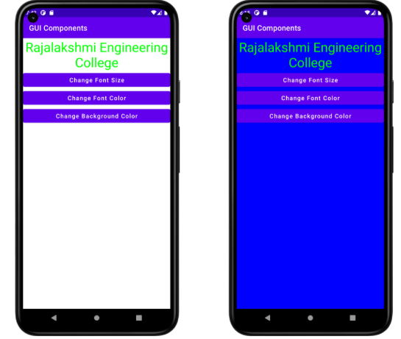

**Result:**

| Thus, the app is created and verified successfully. It changes the font and color of the text and displays a toast message when the button is pressed. |
| --- |